Invitational Report: Alex Shvartsman
Alex Shvartsman

BEFORE THE INVITATIONAL
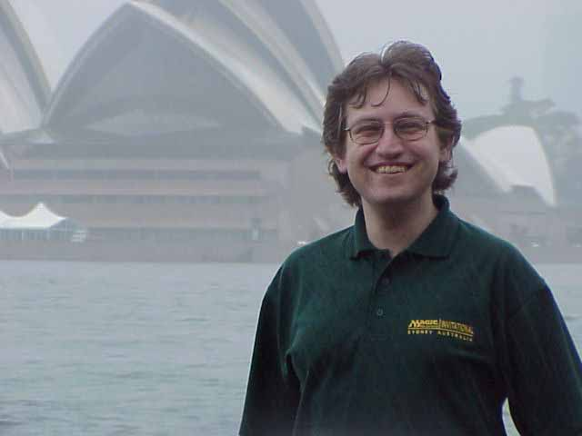
While it has become business as usual to many of the 16 players attending the Magic Invitational in Sydney, for me it was a truly special event.
Two years ago I would have never expected to participate in this tournament. A year ago it was a far-off goal, an accolade to be desired, but far from becoming a reality. Yet a few months back I was watching the Finals match between Jon Finkel and Bob Maher, knowing that my invitation was riding on the outcome.
Toward the end of the 1999 Pro Tour season, I was in contention for Player of the Year title. Although my mediocre performance at Worlds prevented me from catching up to Darwin Kastle in the race, it did leave me with a total of 58 professional points - the highest rated player without a Pro Tour win that season.
Had Maher won the World Championships, it would leave Finkel in the exact same shoes. He would have a total of 58 points for the season, and he would be without a Pro Tour win. At that point, Wizards of the Coast would have to somehow choose between us. I had no illusions as to who they would choose :)
Fortunately for me, Finkel defeated Maher, who was already invited for winning Pro Tour: Chicago. Everyone involved got to go to Sydney in a few months' time. I had an extra reason to look forward to the trip - the final day of the Invitational happened to fall on November 19 - my 25th birthday.

My initial plan was to playtest heavily for this tournament. After all, it was a perfect opportunity to prove I can play with the best. However, real life does not quite work that way. First there was Pro Tour: New York and the Masters Series, both of which required a lot of practice. Then I realized that I would be traveling for the entire month of November and should do as much Type 2 playtesting for PT Chicago as possible before I left. So I ended up doing no testing whatsoever. I put together a deck I liked in theory for Block and Darren di Battista e-mailed me an interesting Type 1 deck. Deck lists and more about both formats further down.
Having thrown together as many of the cards I might need in Sydney as I had the time to gather, I was off on my LONG trip.
By long, I do not just mean a week in Australia. We're talking LONG here, even for someone who travels as much as I have. My plan was to attend Grand Prix: Kyoto in Japan, from there fly to Australia, then return BACK to Japan and, after a few more days spent there on business, return to NYC for a single day before leaving for GP Buenos Aires. Upon returning from Buenos Aires, I would be off to PT Chicago only one day later. THAT, is a long trip.
Grand Prix: Kyoto wasn't a success. I played the same Trix variant I used in the Masters Series to a 6-2 record. However, with so many players attending, 6-2 was only enough to put me in 73rd place, causing me to miss day 2 altogether! Alas, I had to put that loss behind me and get ready for a much harder tournament.

TUESDAY-WEDNESDAY
I arrived in Sydney on Tuesday morning, after an overnight flight from Tokyo. As the plane was landing, I caught a glimpse of a beautiful, sunny city of Sydney. Unfortunately that was the last glimpse of sunny Sydney I would have until the last day in Australia. Like in a horrible vacation nightmare, it began raining when I got there and stopped when I was leaving.
Tuesday was all about getting together with everyone. I showed up at the Star City hotel in the morning. This is a giant complex, several blocks long and wide, which includes a 5-star hotel, a casino, a theater, several restaurants and a shopping mall. I could not get over the hotel's name and how happy Pete Hoefling, the owner of Star City Games, would be with this coincidence. I even saved a pen and a notepad with Star City logos and gave them to Pete at PT Chicago.
I got about an hour's rest at the room (which looked pretty much like a normal $150 hotel room at PT hotels, except it probably cost twice that much) when Gary Wise called, organizing the draft in the lobby downstairs. I came down and pretty much spent most of the day drafting, playing and just hanging out with other players and WOTC folk. Most of the hotel staff was extremely friendly and helpful, although the weekend did not go without an obligatory incident where a hotel security guard wanted us to take our cards and go elsewhere. This time around we managed to fight him off and continue playing in the lobby throughout the week.
Wednesday was the photo-op and tour day. We got loaded onto a big tour bus and left in the hands of possibly the worst tour guide I have ever seen. He kept talking about nothing but the Olympic games held recently in his city. On top of that it was pouring cats and dogs, so we could not see much of the city. And yet on top of that, we had to take photos in the rain.
The bus stopped about a city block's distance away from the spot where they wanted to take the pictures, so the players enjoyed a nice run (or walk if one wanted to get really wet) in the rain, followed by a brief and wet photo session. Despite these hardships everyone was in a great mood, and much of the bus ride was spent discussing the cards we submitted for the Invitational.
My card looked like this:
Shard Portal
3
Artifact
(2) Sacrifice Shard Portal: Search your sideboard for a card. Reveal that card to all players and place it in your hand. Replace it in the Sideboard with Shard Portal.
R&D edited the card to go get any card from your collection, worded similarly to Ring of Ma'Ruf. However, it would receive "tournament errata" limiting its use to the sideboard and "removed from game" cards during sanctioned play.
A general sentiment was that the card was a bit broken, but I really think playtesting would prove it was just fine as is. Ah well, perhaps we'll never know.
After the trip I finally got a chance to playtest my Block deck a little. It was a TE/VI Sligh deck. The third set was in question. Alliances seemed an obvious choice, but Lava Hounds (originally recommended by Mike Pustilnik) convinced me to play Weatherlight instead. I also expected more Tradewind Riders in the environment, which would make Thunderbolt a good choice, but fortunately I ended up taking Thunderbolts out in favor of more fast creatures. I got to playtest against my roommate Darwin Kastle, who was playing a Survival strategy based on Ice Age.
This was the first time I got to share a room with Darwin and have only good things to say about him. We have had a great time chatting throughout the weekend and worked well together helping each other practice for the Constructed formats.
It was finally time to play.

THURSDAY
The first format was Duplicate Limited. Each player was to receive the exact same collection of cards, plus any number of basic lands to build a deck out of. To prevent players from sideboarding into each other's decks, Mark Rosewater added a rule of not being allowed to sideboard additional basic lands.
To make the format as wacky as possible, there is always yet another twist. I remember reading about last year's Invitational where players got some unique cards that were made just for this event in their pool of generally horrible cards. A year before pretty much all the cards were ultra-powerful, and so on. So what curve ball would Rosewater through us this year?
I opened the box to find cards I was familiar with... but, of course, with a twist. Each of the cards given to us this time around was a regular Magic card - however, its casting cost was changed! You could play with Black Lotus, but it cost 3 generic mana to bring into play. You could play cards like Preacher for 4WW, Argivian Archaelogist for W, or Mana Drain for 3UU, even Abyss for 1BB!
The card set was full of pretty combos that are really powerful in Limited if you pull them off. How about Aladdin + Thran Forge for example? Or Subterranean Spirit, Spidersilk Armor, Living Lands. Both of those combos saw play multiple times during the three rounds.
Building a good deck out of this set of cards was anything but easy. Given an hour to do it, almost every one of the players spent all the time they had, and wished they had even more time to work on it.
My deck building process went like this: I spent the first ten minutes or so looking through all the cards and laying out the good ones by color in front of me. Within the next five minutes I knew I would be playing green as one of my colors. The greatest problem with this set of cards is that most of the better ones were badly overcosted, so most of the creatures worth playing would cost 5-6 mana, or more! Green had some slightly better-priced creatures (as did red), giving my deck a semblance of beatdown because I could slam a 1/1 on the table on turn 2 and follow it up with a 2/4 on turn 4! I am not kidding, in that format those creatures were fast. The rest of the time was trying to figure out what other color(s) to use.
In the end I settled for black as my second color. It offered some direct removal (Dark Banishing for 5 mana, Bone Shredder for 6) and some recursion with Animate Dead and Hell's Caretaker. I avoided any combo that would involve three cards, but my deck was still flexible with Survival of the Fittest and those good black cards. I found out that I was one of only 3-4 people who stuck to two colors. Apparently it was the right decision, since all of them went 2-1 or better! Choosing green was far less original, as almost every single player played green - it was clearly that good.
It has been a very long time since the tournament now and I do not remember the matches in as much of a detail as I would like, but there were many interesting plays and situations that I do remember, so I will concentrate on those rather than a very detailed description of each individual game.

Round 1 - Mike Long
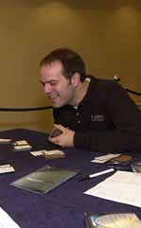
I was hoping to play Mike in one of Constructed formats. First, I know that he didn't prepare for them any more than I did. Second, whatever people out there say about Long, he is an incredibly sharp player and I expected a tough match. This was my first time playing Mike in a serious tournament, though we've drafted against each other in the past.
Game one seemed relatively close, with Mike being on the offensive early on, but I stabilized and began to slowly reduce his life total. With both of us having plenty of mana in play, I knew that I should try and win quickly before Mike drew some powerful card (all I had in play was a Deepwood Tantiv (G3) and some blocker). Mike had a 3/3 in play but let my Tantiv through as he was at a higher life total and he did not want to let me gain life. This did not work out for him, as his life total was just low enough for me to win with the following play:
I cast an Explosive Growth (1G) with kicker on my Tantiv, making it 7/4 and then Berserk (1G), to make it into a 14/4 trampler and win the game.
In the second game Mike got an early Mishra's War Machine out. You won't hear this often, but in THIS format Mishra's War Machine was one of the best cards, because it only cost 5 mana! I had a perfect answer for it though - a Tawnos Coffin. During Mike's attack phase I would phase out his War Machine and then untap the Coffin on my own turn, forcing Mike to deal with Machine's upkeep effect while not gaining any benefit out of it. The loss of cards and life Mike was forced to suffer because of his Machine contrubuted greatly to me being able to win the second game.
Matches 1-0, Games 2-0.

Round 2, Kai Budde
I met Kai Budde in my first international Grand Prix almost two years ago. I beat him at the end of Day 1 and then again in the swiss rounds of Day 2. It did not stop him from making Top 8 however, and taking his revenge on me in the finals, where Kai won the tournament and I was quite happy with my first real Top 8 finish in 2nd place. Kai even titled his tournament report "The Hunt for Alex Shvartsman." We got to hang out together in Barcelona and have been friends ever since.
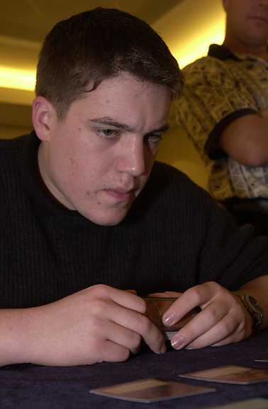
Things looked pretty grim for me in the first game as I got stuck on two lands and was even forced to discard for two turns in a row. However, Kai was unable to present any amount of serious threats to kill me before I got a chance to recover from this mana stall. Eventually I got up to five mana and started casting large creatures one after another, while Kai continued to play land. I won this game, but only because he drew twice as many lands as he drew spells!
The second game was all about me playing a Living Death strategy. I cast a Bone Shredder on one of his guys, Animated it and then began to recur it with Hell's Caretaker which I found with - you guessed it - my Survival of the Fittest (2GG). I don't remember for sure, but I think Kai's draw was not spectacular that game either. Either way, I could not exactly complain.
Matches 2-0, Games 4-0.

Round 3, Trevor Blackwell
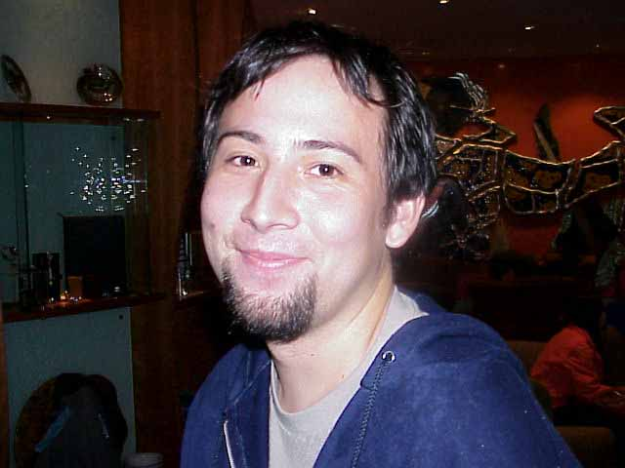
Earlier this year I teamed up with Trevor and Nick Wong to win Team Grand Prix: Nagoya. He is an excellent Limited player and I would much rather sit beside him than in the seat against him. I played Trevor once before at Pro Tour: New York '99 with both of us at 2-0 and lost because of a very dumb mistake I made. I was resolved not to repeat that experience here.
Game one was very close, with many difficult interactions to keep track of. Trevor was one of the very few players who was not actually playing green, so it would be interesting. Trevor is a relatively slow player, and he was really enjoying the fact that there are no time limits for this tournament. I had a watch and timed him, and I know for a fact that he thought for ten minutes straight during one of the turns!
While Trevor is considering his play, I am going to describe the venue. Saturday and Sunday matches would take place at the Grand Prix site. Until then, a room was rented at the hotel itself. About a dozen local spectators showed up on Thursday and Friday to watch us play, but it was not crowded at all. The room was decorated with posters depicting Invitational competitors and listing their top finishes throughout the 1999-2000 season. They also made special cards with each of our names on them that were placed on the table so that the spectators would know who they are watching play.
We did have a spectator watching our game and I finally broke Trevor out of his stupor by offering to perform a little song and dance for our faithful fan to make sure he did not die of boredom. The game took a while, but I managed to win a close one. (Note how I slyly hide the fact that I remember no details whatsoever about this particular game, by writing about all sorts of other stuff.) If I remember right, he got an Abyss in play, but I was able to win by attacking with an artifact creature and eventually using Explosive Growth to finish the game.
Second game was pretty complicated as well. There were Tawnos' Coffin on both sides of the table and although I got Trevor down to very few life points, he had my only offensive creature locked up in the Coffin. I was taking some damage from his attackers, using my own Coffin to remove the largest one each turn.
I was waiting for Trevor to tap out, and finally he did. At the end of his turn I used an Emerald Charm (1G) to untap his Tawnos Coffin!!! This let my monster out and able to attack. On my turn I untapped my own Coffin and used it to remove the creature Trevor just summoned, then attack for the win.
Matches 3-0 Games 6-0
I felt great about this format. I was confident that I built my deck well overall (though I would have changed a couple of cards if I had to do it again) and I was in the lead of the pack along with Jon Finkel, who played red-green, if I am not mistaken.

BRING YOUR OWN BLOCK
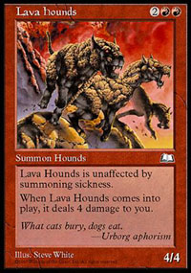
Who let the dogs out?
Next up was the Bring Your Own Block format. Each player got to build their deck out of ANY combination of the basic set (between Ice Age and Invasion), 2nd set (between Homelands and Nemesis) and 3rd set (between Alliances and Prophecy).
The most popular strategy was mono-red. Most players opted for either a Tempest/Visions/Alliances playing an aggressive deck, or Tempest/Nemesis/Alliances for the land destruction strategy with Pillage, Stone Rain, and Avalanche Riders. Just about everyone was either playing monored or some serious anti-red hate (Gary Wise sideboarded multiple copies of Chill and COP: Red). I made a last-second decision to sideboard my favorite Magic card - Steel Golem! Several other invitees mocked the Golem. Others simply got confused trying to figure out just what I was going to play. No one thought I would sideboard it in a Sligh deck. In fact, not only did I find an excuse to play my favorite card, I actually think it was a good sideboard choice. It gave me a chance against decks that might drop a second turn Chill, and it would be pretty good against other Sligh decks (we both drop our fast mana guys and burn the opponent's guys and then this 3-4 monster shows up and either dominates the tables, warrants a Fireblast or takes away two of their burn spells). Of course it was not quite a Phyrexian War Beast or Balduvian Horde, but I did not feel like switching my third set at that point. This is the deck I ended up playing:
Main Deck |  | Sideboard
4 Mogg Conscripts  4 Canyon Wildcat  4 Mogg Fanatic  4 Jackal Pup  4 Fireslinger  4 Viashino Sandstalker | 4 Lava Hound  4 Fireblast  4 Kindle  1 Goblin Bombardment  4 Wasteland  19 Mountain | 3 Phyrexian Furnace  4 Bottle Gnomes  2 Firestorm  2 Boil  4 Steel Golem
The coolest deck in the format was one played by Ishii Yoshikazu. He was the only player to use Invasion and he managed to build a Fires deck with Blastoderms, Saproling Bursts - the works. His deck was perfect for this format and only bad matchups caused him to go 1-2. He won the first match he played and everyone predicted that he would win the format at 3-0.

Round 4: Ben Rubin
I've always respected Ben for his calm, quiet demeanor and thoughtful play. He is every bit as good as anyone at this Invitational and I did not expect an easy match. Last time we played, Ben beat me 2-1 at Pro Tour: Los Angeles, forcing me into a 1-2 bracket.
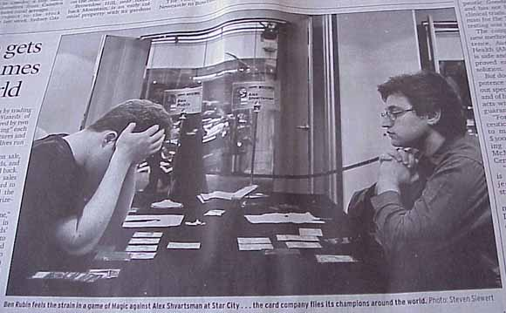
Alex and Ben get a little media coverage
Ben opened with Mountain, Mogg Fanatic so I was quite sure he was playing Sligh - until he played a Reflecting Pool a turn later! I suspected CounterPhoenix, but was not quite sure of this until several more turns into the game. Fortunately this matchup is extremely favorable for me, and the first game was over in a few minutes.
I was really afraid of Chill, but it did not show up in the second game. My early offensive was not fast enough, and Rubin stabilized at a very low life total. He was able to steal my Lava Hounds with Legacy's Alure - but not until they attacked him once, bringing his life total down to 1 point.
Hounds turned on me and I had only a few turns to draw either a direct damage spell or a Mogg Fanatic.
I kept drawing land or creatures, which could not do much since Ben was recursing a Shard Phoenix. On the last possible turn I drew a Kindle and managed another 2-0 win.
Matches 4-0 Games 8-0
During this match a photographer kept taking snaps of our games, and seemed disappointed it was over so quickly as he wanted more pictures. We did not know who he was at the time - until the next day's copy of Sydney Morning Herald came out! This is one of the larger newspapers in Sydney, akin to our New York Times or Daily News. There was an article about the Invitational, and although neither Ben nor I were mentioned in the article itself, a large picture of us playing the match was in there!
I made sure to get a few copies of the paper to bring home with me as a souvenir.

Round 5: Ryan Fuller
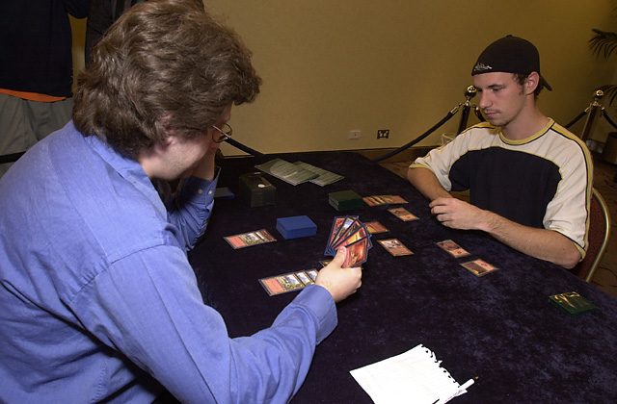
I got to hang out with Ryan and his girlfriend Jamielynn while in Japan and they are really nice folk. I have not played Ryan in a major tournament up until that point, but it seems I've developed a habit of being his nightmare opponent since defeating him in the single elimination Masters tournament and knocking him out of contention for Day 2 in PT Chicago.
Ryan was playing a Ponza deck. Fortunately for me, I drew enough mana to get a Lava Hound out, a card that is difficult for his deck to deal with, and it went all the way. I sideboarded out some of my higher casting cost spells. I did not have a specific sideboard against Ponza. I knew that Mike Long and Trevor Blackwell were both going to use this strategy, but I already faced both of them. I did bring in Bottle Gnomes and Firestorms. Fuller made fun of me a little in his Invitational report for boarding this card in, but I think it was a right call. It was one of a few ways for me to deal with his large monsters (Balduvian Horde, Rathi Dragon) that I would have to face after sideboard. It was also a chance for me to get back into the game if his land destruction strategy succeeded and left me unable to cast most other spells. I did manage to kill his Rathi Dragon and some other guys with a Firestorm.
Second game was close, but Ryan got that one, my first game loss in the tournament. In the third game however, Ryan disrupted my land a bit but proceeded to draw five lands in a row, which allowed me to recover. Both of us were at extremely low life totals. Toward the end, he was at one life with a Bottle Gnome in play and I had two Mountains. I cast a Mogg Fanatic and Ryan chose not to sacrifice his Gnome in response. While this was not necessarily a mistake, it was the play that allowed me to win the game. I shot the Fanatic at him. Ryan responded by sacrificing the Gnome to gain 3 life. That went on the stack, and I Firestormed him for 1 in response. Phew. That was a really close one.
Matches 5-0 Games 10-1
I was quite happy with the result - being on top of the standings after the first day. Like most players there, I did not care all that much about winning the tournament, but I really wanted to make sure I did not finish last and, if possible, finish in the top 50% of the standings. I felt that would be sufficient proof that I belong among this elite group of players.
I went to check out a local game store in the evening, with Nick Wong and several other Singaporean players who were here for the Grand Prix. It was "trade night" at the local store and we wanted to buy/trade for cards. Unfortunately, it seems there were no people who actually had many good cards there. I picked up some stuff, not that much. We got some dinner at a Greek place and I headed back to the hotel.

FRIDAY

Round 6: Gary Wise
I have played Gary countless times and it is always a pleasure. He really has fun playing the games, win or lose, and its an attitude I deeply respect. This time however, I was far from happy about this matchup. Gary is playing a CounterPost strategy. An easy win for me in game one, but a nightmare after Sideboard, where I would have to face 3 Chill 4 COP Red!
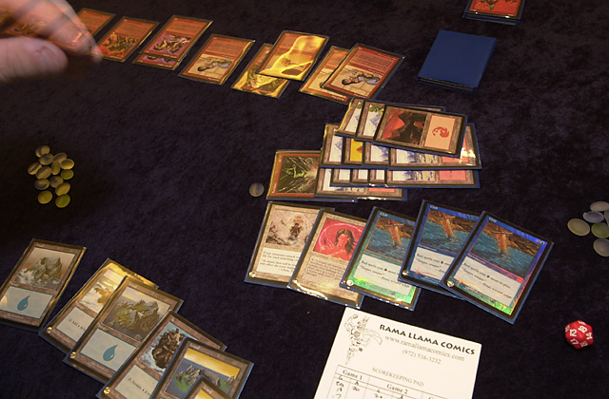
Game one went according to plan, with me quickly smashing his face. Unfortunately, game two seemed to be going according to plan as well. Little did I know, that it would be the coolest game I played this entire tournament.
I dealt some early damage, but was quickly shut down by a vicious combo of COP Red + many, many lands. I drew my Steel Golems, but Gary was able to either counter or Disenchant them (he knew about my tech and kept Disenchants in at that point I guess). Chill got onto the table a bit too late as I had plenty of mana already. However, I could not force any damage through. I was pretty sure that Gary was not playing any global removal spells, so I just kept on casting my guys.
I drew several Wastelands and was able to take out three of Gary's Outposts before they made any significant amount of guys. Gary kept on cycling through his deck to find the fourth Outpost and finally found it with about 20 cards left in his library. Little "Dudes" began appearing one at a time.
At this point I realized that I could not possibly win on damage. However, decking Gary became a real possibility. I began unloading my burn spells on his dudes, one at a time as there were multiple Chills in play now.
We had a great time summoning the reporters and photographers to take a snap of me tapping 12 mana to hard-cast a Fireblast on an Outpost token!
With two cards left in his library, Gary went for an all-out attack. I blocked all of his guys and shot a few with my Fireslingers. Gary pretended that he was about to cast Ramosian Rally, which would have wrecked me totally. Fortunately this was block, and he was playing Tempest, so I was not exactly scared.
At this point Gary was left with no creatures and only two turns to draw anything, while I still had four or five blockers. I managed to successfully deck him!
Matches 6-0 Games 12-1

SOLOMON DRAFT
Next up was Solomon draft. I was kind of worried about this format, since I never really got a chance to play it much. Some years ago my friend Ben Bleiweiss challenged me to a game of Solomon and crushed me thoroughly. I played against Justin Gary at GP Manchester and he beat me, but at least it was close.

Round 7: Yoshikazu Ishii
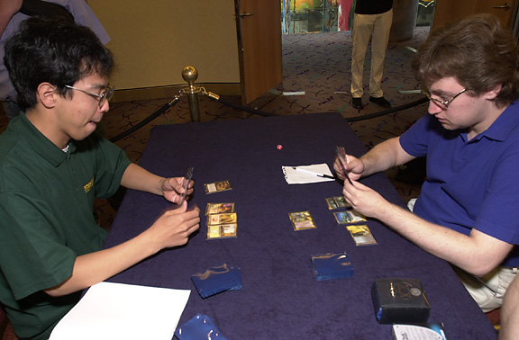
Ishii was one of a few players I did not really know before the tournament. I am familiar with many of the top Japanese players, but I never crossed paths with this winner of the very first GP Kyoto. (Major slops to whoever organized his travel to the Inviational in such a way that he was unable to attend GP Kyoto even while Ryan Fuller, Mike Long and I were there)
Once again, this is one of those formats where Mark does his wacky thing. Ishii opens the first pack and I learn that the theme of this draft is gold cards. Every card in the pack is either gold, an artifact that produces multiple colors of mana, or a land that does the same.
I think that I drafted slightly better overall, but it was pretty close. Both of our decks were pretty horrible as neither of us had much experience with this format. Both of us were forced to play 4 colors. Most of the 16 players ended up with 4 color decks in this format. There were just a couple of 3 color ones and few five color ones. Nothing even close to a two-color strategy made an appearance.
I don't remember much about this match, except that it went to game 3 and Ishii should have won. He made a mistake, forgetting that I cannot activate a Smoldering Tar as an instant, allowing me to burn him out with Energy Bolt on the following turn. My lucky streak continued, placing me as a sole 7-0.
Matches 7-0 Games 14-2

Round 8 - Noah Boeken
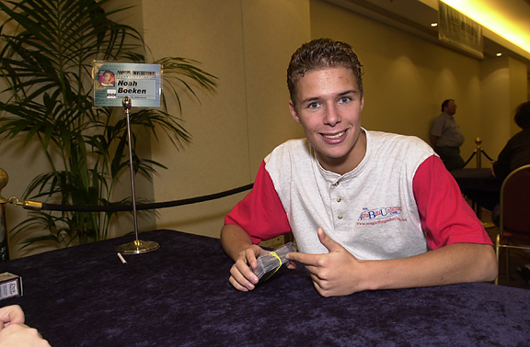
While I may "own" Ryan Fuller based on our last few matches, his teammate Noah Boeken definitely owns me. He beats me on the regular basis in money draft and even defeated me at GP Manchester recently. Could I finally get some revenge?
It seemed that way during the draft. This time around the theme was Legends. Noah did not appreciate the power of certain cards in this environment - cards like Empress Galina (when half of your creatures or more are Legends) and Tsabo Tavoc! I was able to get both of those and many other good cards at little cost.
I won the first game easily. Second game seemed almost locked, but Noah did some impressive top-decking and managed a really amazing comeback. In the third game I had an advantage once more, but Noah managed to win that one too, giving me my first match loss of the tournament.
I felt that I out-drafted Noah this time and should have won the match. On the other hand, I should have lost the match against Ishii the round before, so I could not really complain.
Matches 7-1 Games 15-4

Round 9 - Bob Maher
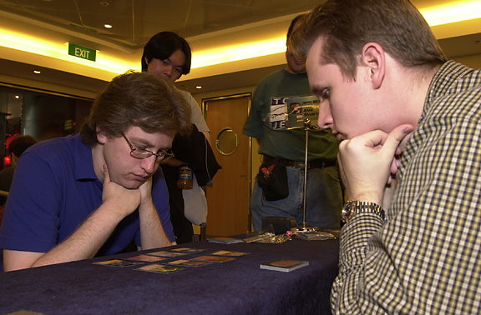
Maher beat me at Nationals (but then who didn't) and the only other time we faced each other was in money draft, where I won. This was really not the format I would ever want to face Bob in though. Unlike most of us, he has had plenty of experience with Solomon Draft and plays it regularly.
I got totally out-drafted. To the point where I could have probably won no more than 25% of the games. The theme of the draft was colors - with a ton of cards that give creature bonuses or produce various effects based on the color of permanents in play - cards like Zanam Djinn, Lightning Dart and Hibernation. It was more difficult than the previous two formats but Bob handled it superbly.
He crushed me 2-0, but I was still in good shape, still tied for the first place going into day 3.
Matches 7-2 Games 15-6

SATURDAY
This was the first day at the Grand Prix venue - in the center of town. We were kept away from the action of the Grand Prix though. The main event took place one floor up while side tournaments, artist signings and dealer tables were in the large room next door. We were in a smaller room, but some local players came down to watch us play.

Auction of Champions
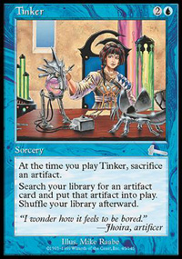
The morning began with the most anticipated format of the tournament - an auction of champions. As the #1 player in the standings, I was to place the opening bid of the auction. My plan was to aggressively bid on Dave Price's monored deck, though I would stay open to other bargains, especially Tinker decks like Finkel's and Budde's which I felt were great deals for the price they might cost me.
I opened the bidding with Jon Finkel's Worlds deck but it went for a slightly higher price than I was willing to pay. Someone ended up getting it at 6 cards 15 life. Auction went on, with bidding lighter and less vicious than I expected. Next Tinker deck up was that of Casey McCarrel. I figured 6-20 would be the lowest I am willing to bid on that one. Apparently, no one was willing to bid lower, so I ended up with Casey's deck.
I should have done a little more testing though. The deck "mulliganed" to six a lot worse than I expected it to.

Round 10: Darwin Kastle
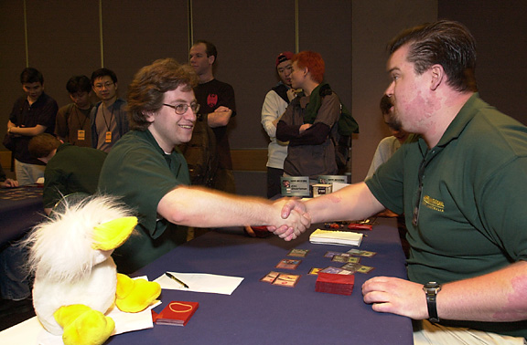
I was glad to face Darwin in Auction of Champions rather than Type 1, since we helped each other playtest Type 1 decks the night before. Darwin and I played a number of times. He only beat me once but did so when it counted - at 6-1 record in Grand Prix: Philadelphia. This match looked good as Darwin ended up with what everyone felt was the weakest deck - that of Olle Rade.
My draw was very mediocre in the first game, but not bad enough to mulligan to five. Darwin dropped a horde of creatures and started sending them in. It looked as though I am about to stabilize - I was one turn away from casting a Crater Hellion (able to pay echo on it, too) - but Darwin drew both of his Giant Growths and was able to kill me a turn before I expected him to.
In the second game Darwin drew one of his two Pyroblasts and was able to counter my Tinker. I never quite recovered from that and fell to his fast creatures once again. It was not the matchup I expected to lose, but Darwin felt confident that Olle's deck is a lot better than it was given credit for. Apparently he was right, as he went on to do very well with it.
Matches 7-3 Games 15-8

Round 11: Gerardo Godinez
We've never played before, but having met at the Invitational we hung out and played each other at Pro Tour Chicago, as well as met at GP Buenos Aires. I got my revenge on Gerardo in Chicago, beating him in the match the winner of each was guaranteed a top 32 finish.
This particular matchup was nightmarish. Godinez got Champheng's white weenie deck - with Disenchants, Swords to Plowshares and even Divine Offerings in the sideboard. A matchup that would be almost impossible for me to win.
Gerardo smashed me in the first game. In the second he mulliganed to 5 (from 6-18) and did not draw any land other than Kjeldoran Outpost, but decided to keep that hand. Even with this handicap in place, I only barely won that game. In the third game it was my turn to get mana screwed, and Godinez' White Knights walked all over me.
Matches 7-4 Games 16-10

Round 12: Zvi Mowshowitz
I've known Zvi far longer than anyone else at the Inviational. We both started out at Neutral Ground: New York and slowly worked our way up from casual players to serious tournament competitors. I generally tend to be very lucky when facing Zvi - I don't believe I've ever lost to him in a title tournament.
In this tournament Zvi actively went after Mike Long's ProsBloom deck - I still don't understand why. The deck seems terrible to me, especially under Sixth Edition rules where you can no longer continue "going off" while at zero life.
My deck was one of Zvi's good matchups - I had no countermagic nor could I kill him very quickly. He successfully combo'ed me out in the first game. In the second game he managed to go off, but the deck betrayed him and he fizzled, leaving me with a handful of powerful cards, thanks to Prosperity. Hibernation was very helpful against him too, because he was under the threat of me bouncing Cadaverous Bloom and Squandered Resources in response to him casting Natural Balance.
In the third game my deck finally worked right, and I was able to lock Zvi up in a Mishra Helix prison by turn 4. There is only one way for a Bloom deck to escape this lock: sacrifice a Bad River to get an untapped land in response to me activating the Helix, then play another land and cast Squandered Resources. However, I had Voltaic Key and plenty of mana available, making sure that the lock was 100% secure.
Matches 8-4 Games 18-11

Type 1
Only one format was left, and I had to play exclusively against the Deadguys. I knew that Finkel would play a pretty standard 5 color control deck, Pikula would play heavily anti-combo Necro and Price would likely play Cuneo's artifact deck.
Before I left for the tournament, Darren di Battista handed me his new Type 1 deck - a U/B control strategy somewhat similar to a monoblue deck I worked on last year. I liked the idea of splashing Black for Mind Twist and Diabolic Edicts (in Type 1 they are as good as Swords to Plowshares if not better). However, the deck just did not perform too well in testing against Darwin's Zoo deck nor Pikula's Necro deck.
Main Deck |  | Sideboard
3 Morphling  4 Force of Will  4 Ophidian  2 Misdirection  3 Diabolic Edict  4 Mana Drain  3 Fact or Fiction  1 Mind Twist  1 Vampiric Tutor  1 Time Walk  1 Ancestral Recall  1 Library of Alexandria  1 Mox Pearl  1 Mox Sapphire  1 Mox Emerald | 1 Mox Jet  1 Mox Ruby  1 Black Lotus  1 Balance  1 Sol Ring  1 Yawgmoth's Will  1 Demonic Tutor  1 Mystical Tutor  1 Disenchant  4 City of Brass  4 Wasteland  1 Strip Mine  1 Tolarian Academy  4 Underground Sea  4 Island  2 Tundra
I ended up handing this deck to Ryan Fuller, who did not have any kind of Type 1 deck built, and building a Zoo'ish type deck instead. It looked pretty good on paper (at least to me it did) but apparently it was not quite good enough.
Main Deck |  | Sideboard
1 Mind Twist  4 Blastoderm  3 Serendib Efreet  3 Tropical Island  4 Volcanic Island  4 Taiga  4 City of Brass  4 Wasteland  1 Strip Mine  1 Sol Ring  1 Mox Pearl  1 Mox Ruby  1 Mox Jet  1 Mox Sapphire | 1 Mox Emerald  1 Black Lotus  1 Ancestral Recall  1 Time Walk  4 Gorilla Shaman  1 Vampiric Tutor  1 Demonic Tutor  1 Seal of Cleansing  1 Regrowth  2 Pyroblast  4 Lightning Bolt  2 Incinerate  2 Kird Ape  4 Jackal Pup | 1 Time twister  2 Teferi's Response  2 Disenchant  1 Red Elemental Blast  2 Pyroblast  4 Hydroblast  1 Circle of Protection Black  1 Circle of Protection Red  1 Masticore

Round 13: Chris Pikula
I don't think I ever played Chris before in any tournament, but we playtested during the week and his Necro deck smashed my U/B control deck's face. This matchup however was really good, and I expected to win.
Game one began fast and furious as Type 1 usually is. Pikula pulled off a 3 point Mind Twist on the first turn. This however did not stop me from playing a first turn Blastoderm - exactly what my deck wants to do in this matchup! However, Pikula was ready with a Diabolic Edict, and then another for my second turn Serendib Efreet.
Pikula went down to 5 life with Necropotence to find these Edicts, so it still looked pretty good. He cast a Juzam and needed me to draw nothing for four turns in order to win. Unfortunately, he got his wish. I drew 3 lands/moxes in a row and my last draw was a Jackal Pup - which could not block big mean Juzam. Down to one life, Pikula got the first game.
In the second game I played a first turn COP Black, but had no answer to a turn 2 Masticore Pikula cast. Masticore went all the way, while I was unable to find an Incinerate.
Matches 8-5 Games 18-13

Round 14: Jon Finkel
What can you say about the best player in the game that hasn't been said before? I respect Jon deeply, but I do not fear playing him as much as so many other players seem to. I still hold a 6-0 lifetime record in Type 2 against him (most of these wins took place before he was really good - but then I was not good back then either!) I felt that the matchup I had here was quite reasonable.
Of course, Finkel is Finkel.
He smashed me 2-0. I don't recall the details too well - you know, your mind tries to protect your sanity by selectively forgetting extremely unpleasant experiences.
We went on to play a bunch more games, and it went very even, so perhaps my deck isn't really horrible? I mean going 0-3 at the Invitational does not necessarily mean the deck sucks.
Matches 8-6 Games 18-15

Round 15: Dave Price
In the final round, I had a chance to play a role of a spoiler. I could no longer make top 2 myself, but I could prevent Dave from doing so by winning the match. Even if Dave won though, he was more likely to finish in third place, just behind Ben Rubin.
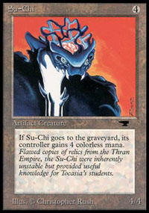
In the first game there was a close damage race, but in the end Dave's Su-Chi got me. In the second and equally close game, I managed to win by forcing Dave to take four points of mana burn, having used Seal of Cleansing to kill Su-Chi. As Matt Vienneau pointed out, "Live by the Su-Chi, die by the Su-Chi."
Final game went to Dave, as his artifact creatures came out fast and pounced on me.
Matches 8-7 Games 19-17.
Despite a dismal performance on Day 3, I was very happy with the overall result. I won more matches than I lost, finishing 5th or 6th overall. Certainly a solid finish. I was now done playing tournament Magic for the weekend and had to prepare for a gunslinging session on Sunday.
I had an opportunity to go out to dinner with Mark Rosewater, his wife, and their young daughter. We had a fun evening, talking about a little of everything, but mostly the Invitational. I felt that players should submit their deck lists in advance to prevent extreme "metagaming." Everyone pretty much knew what everyone else was playing, and so many players have gone to extreme to alter their decks based on which opponents they have not faced yet. Knowing my last three opponents certainly gave me a lot of extra information to prepare for the matchups - though in my case it did not do me much good.
Mark listened to the arguments (that were later seconded by some other Invitational players) and said that he would think about it and decide sometime before the next Invitational.
Another reason why this meal is so memorable to me is the dish I ordered. It came with a piece of crocodile meat and a piece of kangaroo meat! Kangaroo tastes sort of gamey, like a wild rabbit perhaps. Crocodile meat is pretty weird and I am at a loss to compare it to anything else I've eaten before. Neither is something I would really enjoy on a regular basis, but I wanted to try these exotic dishes while I had the chance.

SUNDAY
Rubin and Finkel would face off in the finals. For the rest of us, this was the day for gunslinging. And for me, it was my 25th birthday.
I arranged to gunsling a bit later in a day (starting at 2 pm) and spent the morning sightseeing and shopping for gifts. The weather got a little better (though still far from perfect) and I enjoyed just hanging around Sydney, watching both people and sights.
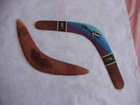
I picked up a ton of souvenirs, including a variety of obligatory boomerangs. I have traveled to many exotic locations over the last few years, and I always make sure to bring something really cool back to add to my "trophy case." I got a hand-carved wooden dragon from Taiwan, a beautiful Chokin vase from Japan, and now a pair of aboriginal-made boomerangs to add to my collection.
Gunslinging was a lot of fun. I got to play some of my wackier decks against Australian players, and was handed a display box of boosters that I was able to give people for beating me, or even for making a really good play. My gunslinging session was cut short though as everyone was required to attend the award ceremony. I did not know this in advance, but the top 4 players received nice trophies, and everyone else got commemorative plaques. As a big fan of trophies in general (I have been advocating trophies for American Grand Prix Top 8's for a while now), I was pleased to get this additional memento of my week in Australia.
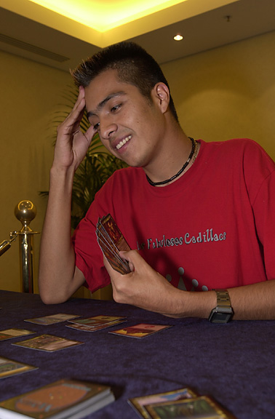
There was a little time left before dinner, and Gerardo Godinez challenged me to some games with our Duplicate Sealed decks. He went 2-1 in the format and his deck was quite good - but I was intent on proving that mine was better!
We got a chance to play a ton of games actually. After a while we were tied at 5-5, and I suggested that we play until one of us wins a total of 10 games. Gerardo agreed. The cards really loved me for a while there, as I won the next 5 games straight, bringing the score to 10-5. I think Gerardo still feels that I tricked him somehow as I started winning right after our deal - but there was nothing on the line and I really just had pretty good draws (and I still think my deck was the better one of the two, so nyah!)
In the evening WOTC took us out to dinner, to a Korean Barbecue place. I generally loathe cooking, not to mention paying a restaurant to cook my own food. However, it was pretty cool this time around. I got a lot of tips on how to mix the raw meat with sauces, garlic and vegetables and ended up with a very tasty meal. Ishii taught everyone who was interested how to eat with chop sticks properly. Even though he does not speak much English, somehow he managed to explain this to me better than many people who have tried previously, though I went back to the good old fork when I realized how long it would take me to eat the rice with chop sticks.
That evening there was more drafting at the hotel lobby, proving that the best way for a bunch of Magic players who just spent the weekend competing in a 15 round tournament to relax, is to play more Magic.

AFTER THE TOURNAMENT (THE AIRLINE HORROR STORY)
I was supposed to board a plane in Sydney, fly to Melbourne and transfer there on to a plane for Japan, spend a day and a half there on business and then fly back to New York. However, Quantas Airlines had other plans for me.
The plane to Melbourne got delayed for about three hours. After that much waiting, Quantas officials told me and a handful of other people expecting to make the same connection that, although the Melbourne flight was now ready to be boarded, the Tokyo plane would not wait for us. We were to stay in Sydney during the day and be put on an evening flight directly from Sydney to Tokyo.
I have been very lucky. Although I fly A LOT, I've never before had any kind of serious delays/cancellations that would affect my travel plans. I guess there is a first time for everything. I spent a day doing some more sightseeing and returned to the airport in the evening.
We boarded the plane and sat in it for several hours, with pilot announcing that we would lift off in just a few minutes every half an hour or so. Eventually he announced that there was a problem with one of the engines. The solution? We would be shipped off to a hotel and put on a different flight next afternoon.
Now I was upset. Not only did this totally destroy my plans, I would not even be able to make my flight back to New York at this schedule! I wanted to speak to someone in charge, only to learn that EVERYTHING closes at the Sydney airport at around 11pm and that there is no one there for me to talk to!
I spent the night at the hotel and went straight to the Quantas supervisor at the check-in area in the morning. I explained my situation to them and asked to be put on a flight to New York instead of a flight to Tokyo. At first they would not do it, but after many threats and much negotiation, they finally agreed to change my ticket so that I could get home around the same time I expected to.
Without further adventures, my trip ended with a LONG, LONG flight home.

AFTERWORD
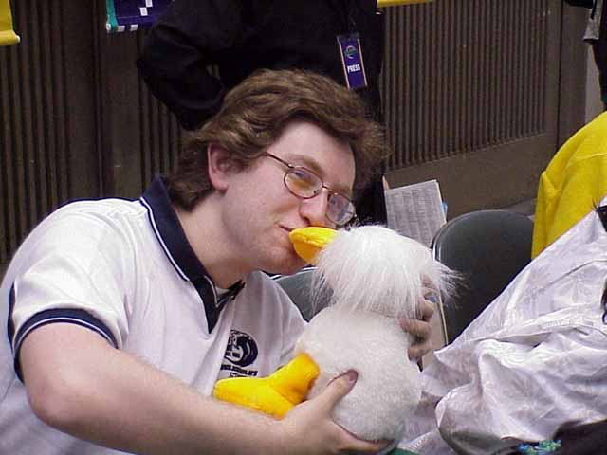
Alex kisses Nick Wong's lucky duck
I may sound dissatisfied or even bitter at some parts of report, but do not take me wrong - the 2000 Invitational in Sydney was a wonderful experience. It was one of the best weeks in my Magic career - one I expect to remember for many years to come.
It seems Wizards have outdone themselves yet again, and next year's Invitational is going to be held in Cape Town, South Africa! It is the only continent I have not been to yet, and I am very eager to go - so don't forget to vote for me next year!
A few words of thanks before I go:
- Mark Rosewater - for masterminding the whole thing.
- Omeed Dariani - for some great chats at dinnertime
- Jeff Donais - for all his help
- WOTC staff - for a very smooth tournament
- The other players - for making the event fun
- Darwin Kastle - for being a great roommate
- Darren di Battista, Justin Gary and Mike Pustilnik - for their help in what little playtesting I did
- Nick Wong, Ben Seck - and everyone else who loaned me cards for last-minute deck changes
- Ray, Chris and everyone else who told me they were reading live coverage and rooting for me
- Alex Shvartsman

